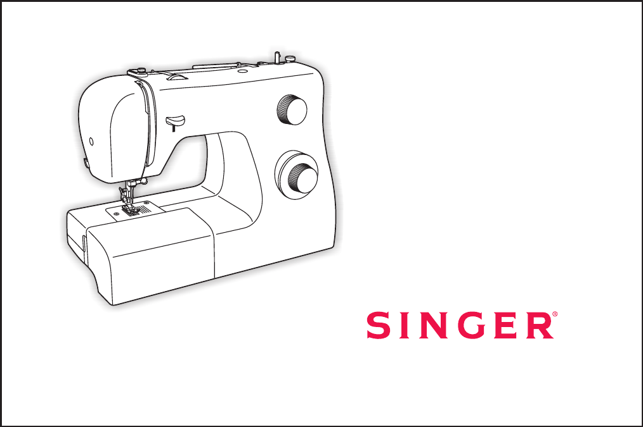
2259 Instruction Manual
When using an electrical appliance, basic safety should always be followed, including the following:
1. An appliance should never be left unattended when plugged in.
2. Always unplug this appliance from the electric outlet immediately after using and before cleaning.
3. Always unplug before re-lamping. Replace bulb with same type rated 10 watts

Read all instructions before using this sewing machine.
1. Do not allow to be used as a toy. Close attention is necessary when this appliance is used by or near children.
2. Use this appliance only for its intended use as described in this manual. Use only attachments recommended by the manufacturer as contained in this manual.
3. Never operate this appliance if it has a damaged cord or plug, if it is not working properly, if it has been dropped or damaged, or dropped into water. Return the appliance to the nearest authorized dealer or service center for examination, repair, electrical or mechanical adjustment.
4. Never operate the appliance with any air openings blocked. Keep ventilation openings of the sewing machine and foot controller free from accumulation of lint, dust, and loose cloth.
5. Keep fingers away from all moving parts. Special care is required around the sewing machine needle.
6. Always use the proper needle plate. The wrong plate can cause the needle to break.
7. Do not use bent needles.
8. Do not pull or push fabric while stitching. It may deflect the needle causing it to break.
9. Switch the sewing machine off ("O") when making any adjustments in the needle area, such as threading needle, changing needle, threading bobbin, or changing presser foot, and the like.
10. Always unplug sewing machine from the electrical outlet when removing covers, lubricating, or when making any other user servicing adjustments mentioned in the instruction manual.
11. Never drop or insert any object into any opening.
12. Do not use outdoors.
13. Do not operate where aerosol spray products are being used or where oxygen is being administered.
14. To disconnect, turn all controls to the off ("O") position, then remove plug from outlet.
15. Do not unplug by pulling on cord. To unplug, grasp the plug, not the cord.

This sewing machine is intended for household use only.
DANGER
SAVE THESE INSTRUCTIONS
- To reduce the risk of electric shock: (110-120V area) or 15 watts (220-240V area).
16. The sound pressure level under normal operating conditions is 75dB(A).
17. Please turn off the machine or unplug when the machine is not operating properly.
18. Never place anything on the foot controller.
19. If the supply cord that is fixed with foot controller is damaged, it must be replaced by the manufacturer or its service agent or a similar qualified person in order to avoid a hazard.
20. This appliance is not intended for use by persons (including children) with reduced physical, sensory or mental capabilities, or lack of experience and knowledge, unless they have been given supervision or instruction concerning use of the appliance by a person responsible for their safety.
21. Children should be supervised to ensure that they do not play with the appliance.
WARNING - To reduce the risk of burns, fire, electric shock, or injury to persons:
IMPORTANT SAFETY INSTRUCTIONS
GB
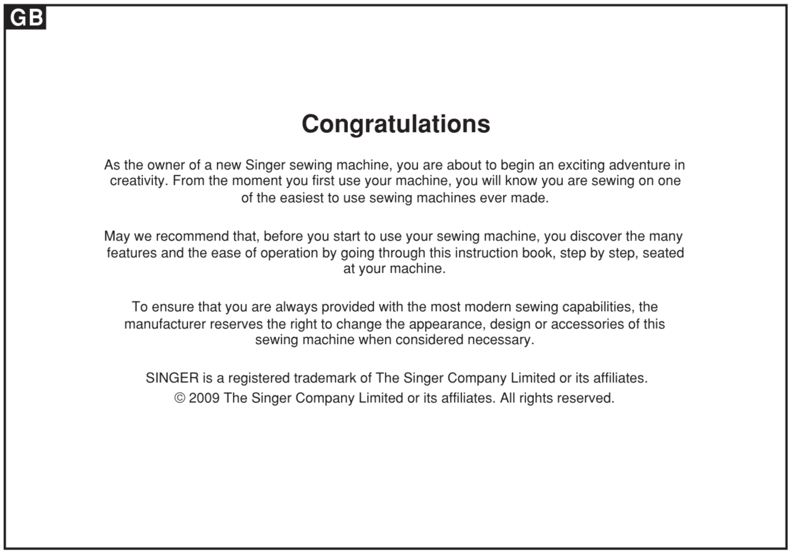
Congratulations
As the owner of a new Singer sewing machine, you are about to begin an exciting adventure in creativity. From the moment you first use your machine, you will know you are sewing on one of the easiest to use sewing machines ever made. May we recommend that, before you start to use your sewing machine, you discover the many features and the ease of operation by going through this instruction book, step by step, seated at your machine.
To ensure that you are always provided with the most modern sewing capabilities, the manufacturer reserves the right to change the appearance, design or accessories of this sewing machine when considered necessary.
SINGER is a registered trademark of The Singer Company Limited or its affiliates.
© 2009 The Singer Company Limited or its affiliates. All rights reserved.
GB
Machine Basics
Threading the Machine
Sewing
General Information
Maintenance and Troubleshooting
Principle Parts of the Machine................................................................................................................................................2/3
Connecting Machine to Power Source ...................................................................................................................................4
Two Step Presser Foot Lifter...................................................................................................................................................5
Accessories .............................................................................................................................................................................6
Winding the Bobbin .................................................................................................................................................................7
Inserting the Bobbin ................................................................................................................................................................8
Thread Tension .......................................................................................................................................................................9
Threading the Upper Thread .................................................................................................................................................10
Raising the Bobbin Thread....................................................................................................................................................11
How to Choose Your Pattern.................................................................................................................................................12
Stitch Length Dial ..................................................................................................................................................................13
Sewing Straight Stitch ...........................................................................................................................................................14
Reverse Sewing/ ...................................................................................................................................................................15
Choosing Stretch Stitch Patterns ..........................................................................................................................................16
Blind Hem..............................................................................................................................................................................17
Buttonholes ...........................................................................................................................................................................18
Sewing on Buttons ................................................................................................................................................................19
Installing the Removable Extension Table ............................................................................................................................20
Attaching the Presser Foot Shank.........................................................................................................................................21
Needle/Fabric/Thread Chart..................................................................................................................................................22
Darning Plate.........................................................................................................................................................................23
Inserting & Changing Needle ................................................................................................................................................24
Changing the Bulb.................................................................................................................................................................25
Troubleshooting Guide ..........................................................................................................................................................26
Removing the Work/Cutting the Thread
List of contents
GB
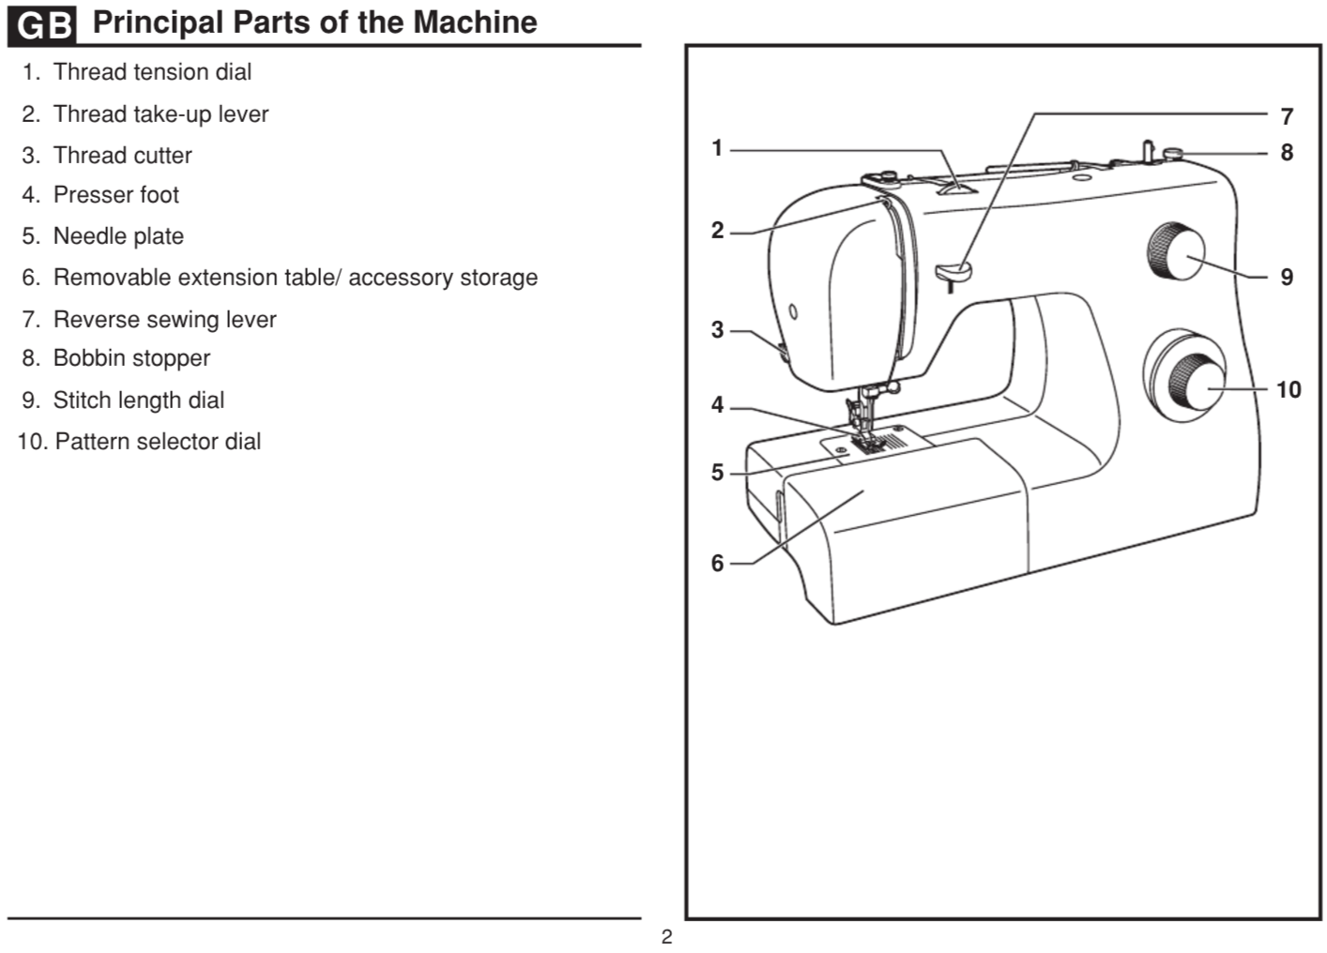
Principal Parts of the Machine
1. Thread tension dial
2. Thread take-up lever
3. Thread cutter
4. Presser foot
5. Needle plate
6. Removable extension table/ accessory storage
7. Reverse sewing lever
8. Bobbin stopper
9. Stitch length dial
10. Pattern selector dial
GB
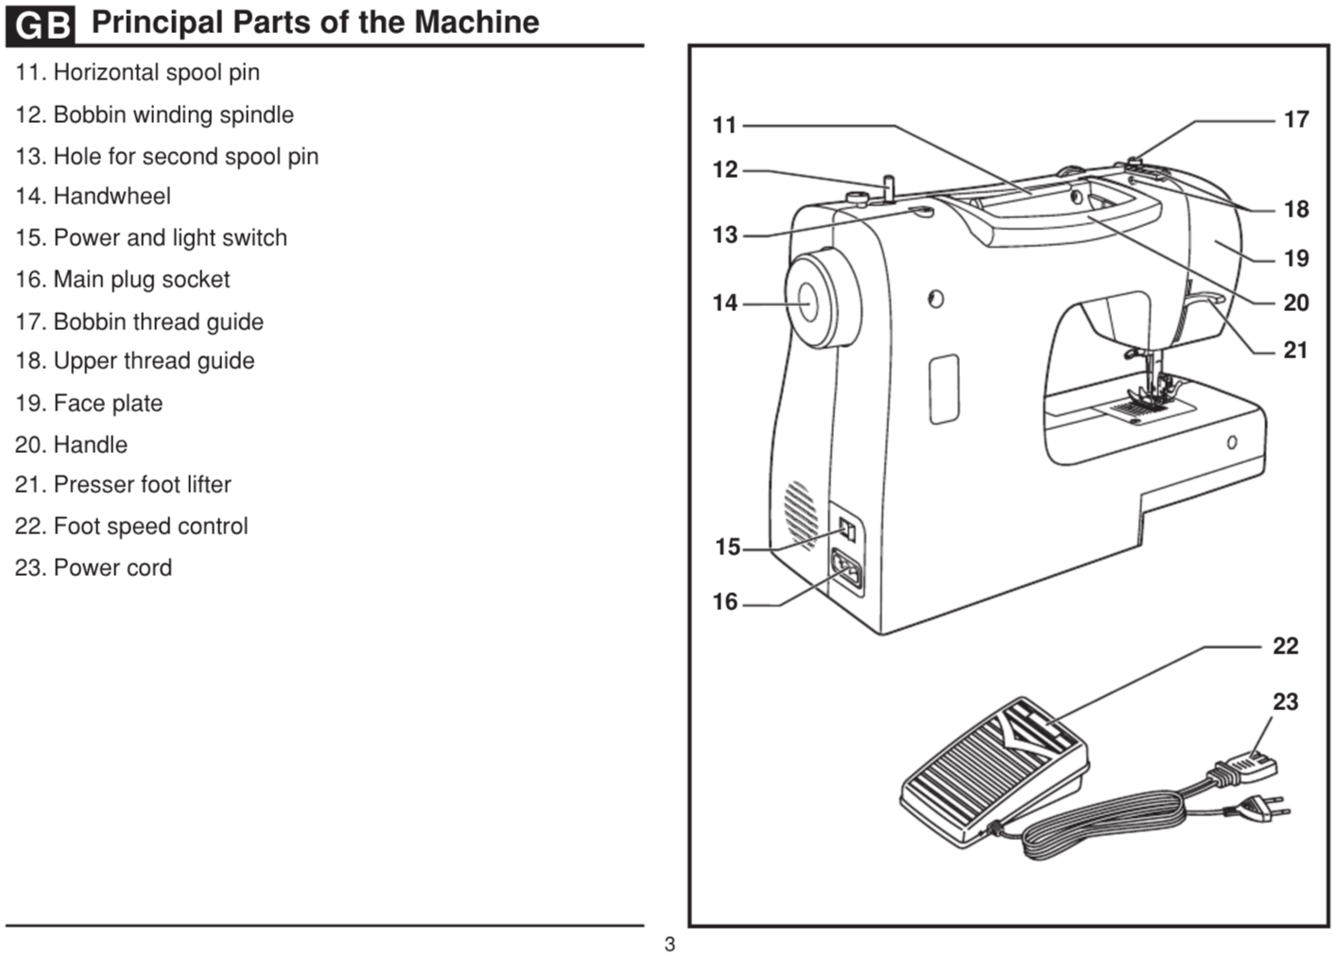
3
11. Horizontal spool pin
12. Bobbin winding spindle
13. Hole for second spool pin
14. Handwheel
15. Power and light switch
16. Main plug socket
17. Bobbin thread guide
18. Upper thread guide
19. Face plate
20. Handle
21. Presser foot lifter
22. Foot speed control
23. Power cord

GB
Principal Parts of the Machine
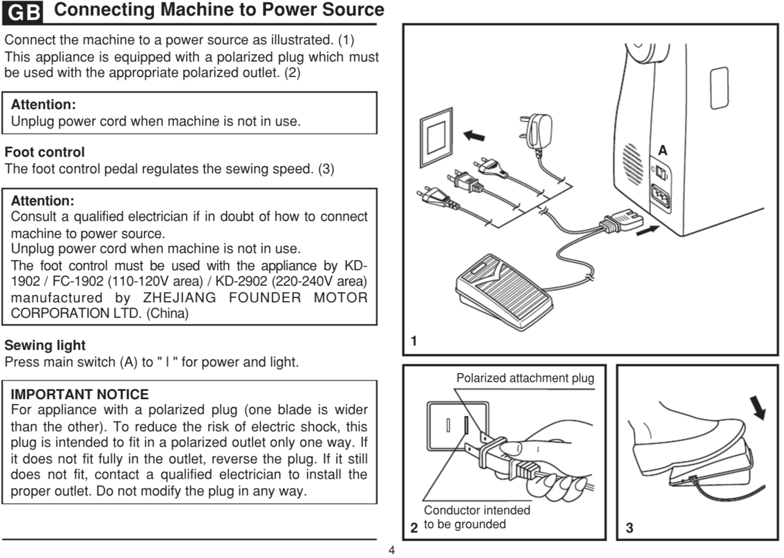
Connecting Machine to Power Source

Connect the machine to a power source as illustrated. (1)
This appliance is equipped with a polarized plug which must be used with the appropriate polarized outlet. (2)
Unplug power cord when machine is not in use.

Attention: Unplug power cord when machine is not in use.
Foot control
The foot control pedal regulates the sewing speed. (3)
Attention: Consult a qualified electrician if in doubt of how to connect machine to power source. The foot control must be used with the appliance by KD- 1902 / (110-120V area) / KD-2902 (220-240V area) manufactured by ZHEJIANG FOUNDER MOTOR CORPORATION LTD. (China)
Sewing light
Press main switch (A) to " l " for power and light.
IMPORTANT NOTICE
For appliance with a polarized plug (one blade is wider than the other). To reduce the risk of electric shock, this plug is intended to fit in a polarized outlet only one way. If it does not fit fully in the outlet, reverse the plug. If it still does not fit, contact a qualified electrician to install the proper outlet. Do not modify the plug in any way.
FC-1902
2 Polarized attachment plug
2 Conductor intended to be grounded
GB
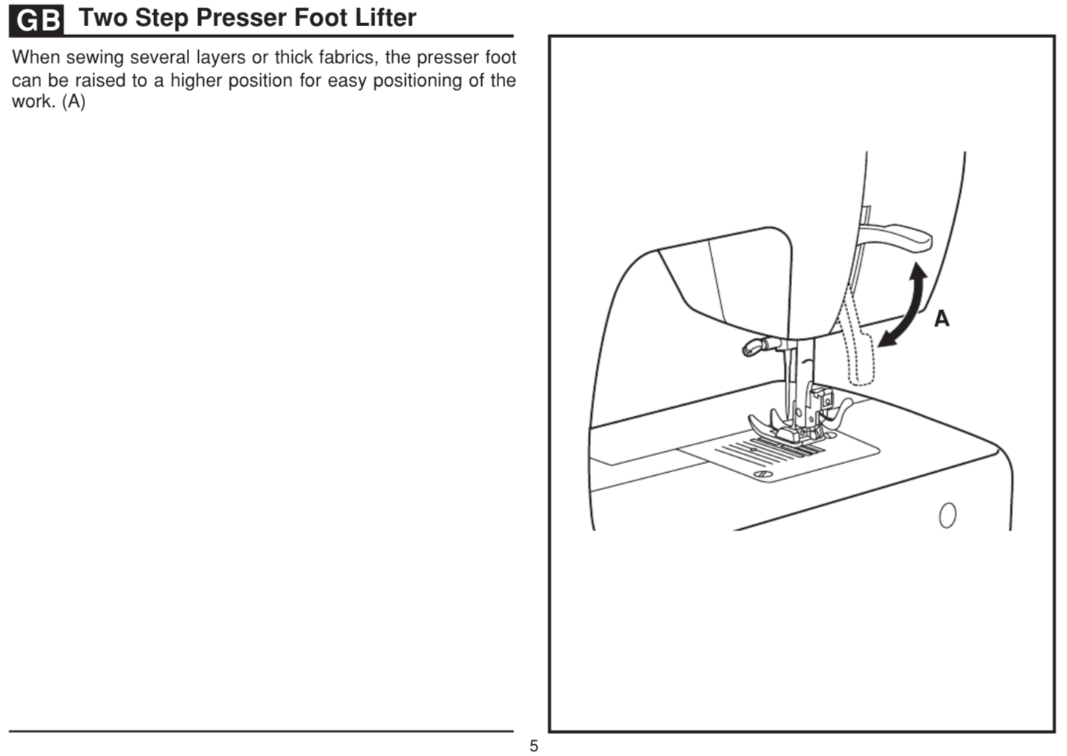
Two Step Presser Foot Lifter
When sewing several layers or thick fabrics, the presser foot can be raised to a higher position for easy positioning of the work. (A)

GB
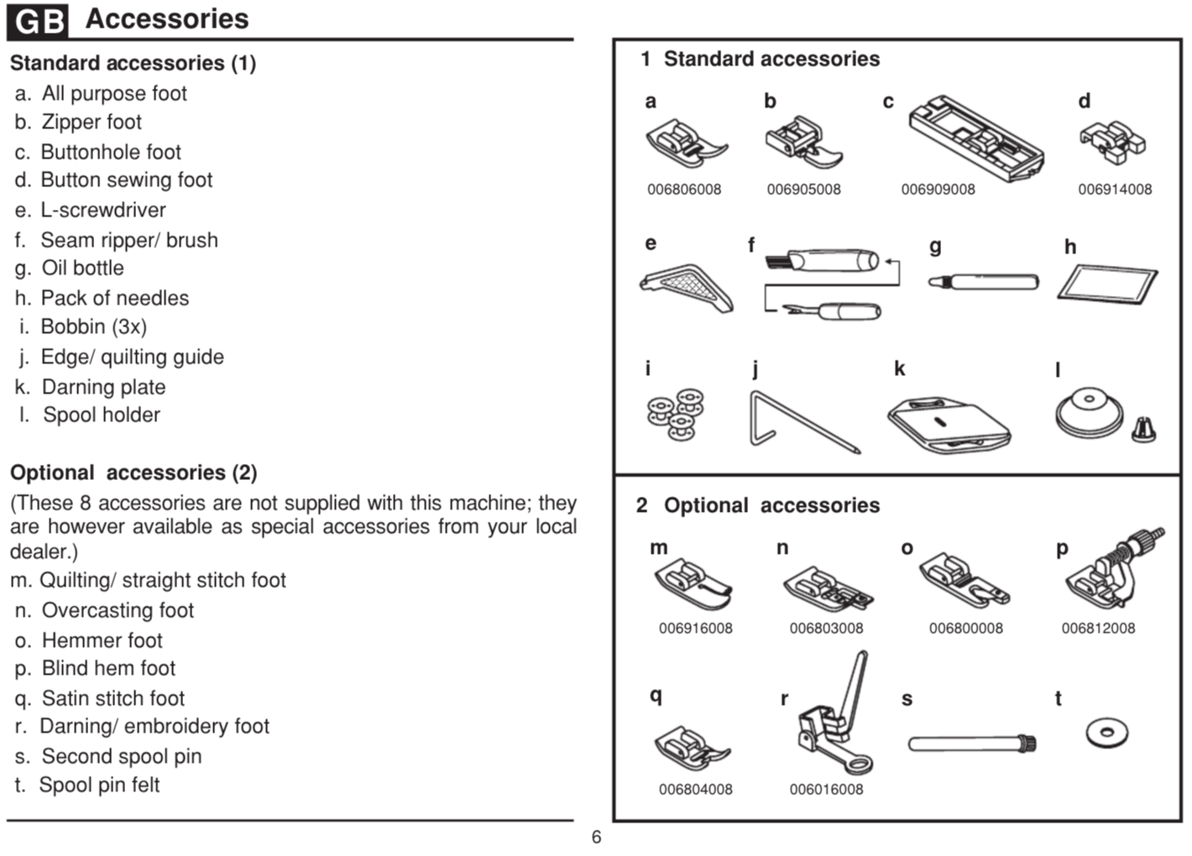
Standard accessories (1)
a. All purpose foot
Buttonhole foot
Button sewing foot
L-screwdriver
Seam ripper/ brush
g. Oil bottle
Pack of needles
Bobbin (3x)
Edge/ quilting guide
l. Spool holder
Optional accessories (2)
(These 8 accessories are not supplied with this machine; they are however available as special accessories from your local dealer.)
m. Quilting/ straight stitch foot
n. Overcasting foot
o. Hemmer foot
p. Blind hem foot
q. Satin stitch foot
r. Darning/ embroidery foot
s. Second spool pin
t. Spool pin felt
b. Zipper foot
c.
k. Darning plate

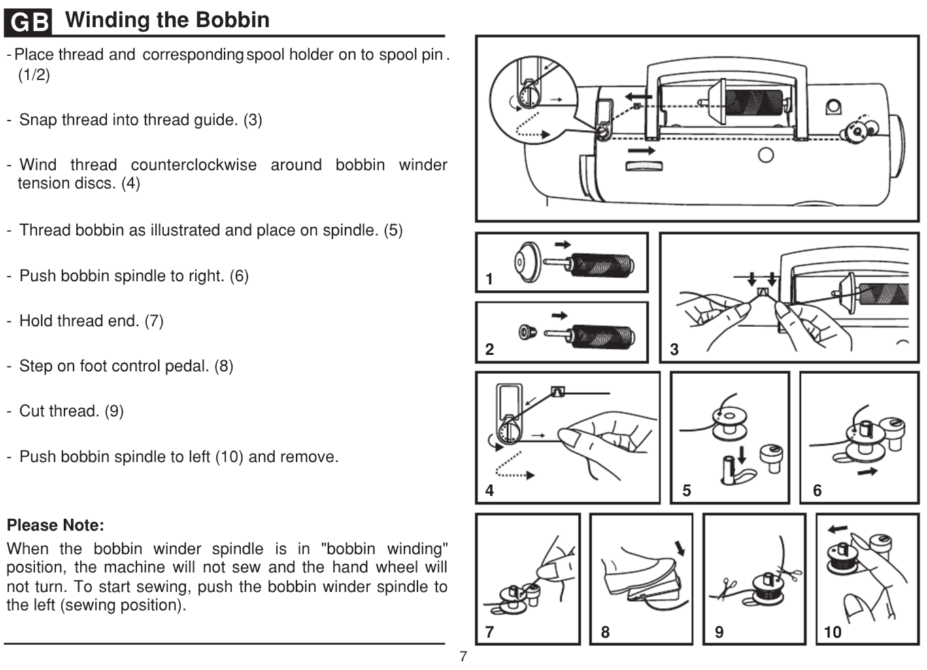
Winding the Bobbin
- Place thread and spool holder onto corresponding spool pin (1/2)
- Snap thread into thread guide. (3)
- Wind thread counter clockwise around bobbin winder tension discs. (4)
- Thread bobbin as illustrated and place on spindle. (5)
- Push bobbin spindle to right. (6)
- Hold thread end. (7)
- Step on foot control pedal. (8)
- Cut thread. (9)
- Push bobbin spindle to left (10) and remove.
Please Note:
When the bobbin winder spindle is in "bobbin winding" position, the machine will not sew and the hand wheel will not turn. To start sewing, push the bobbin winder spindle to the left (sewing position).

B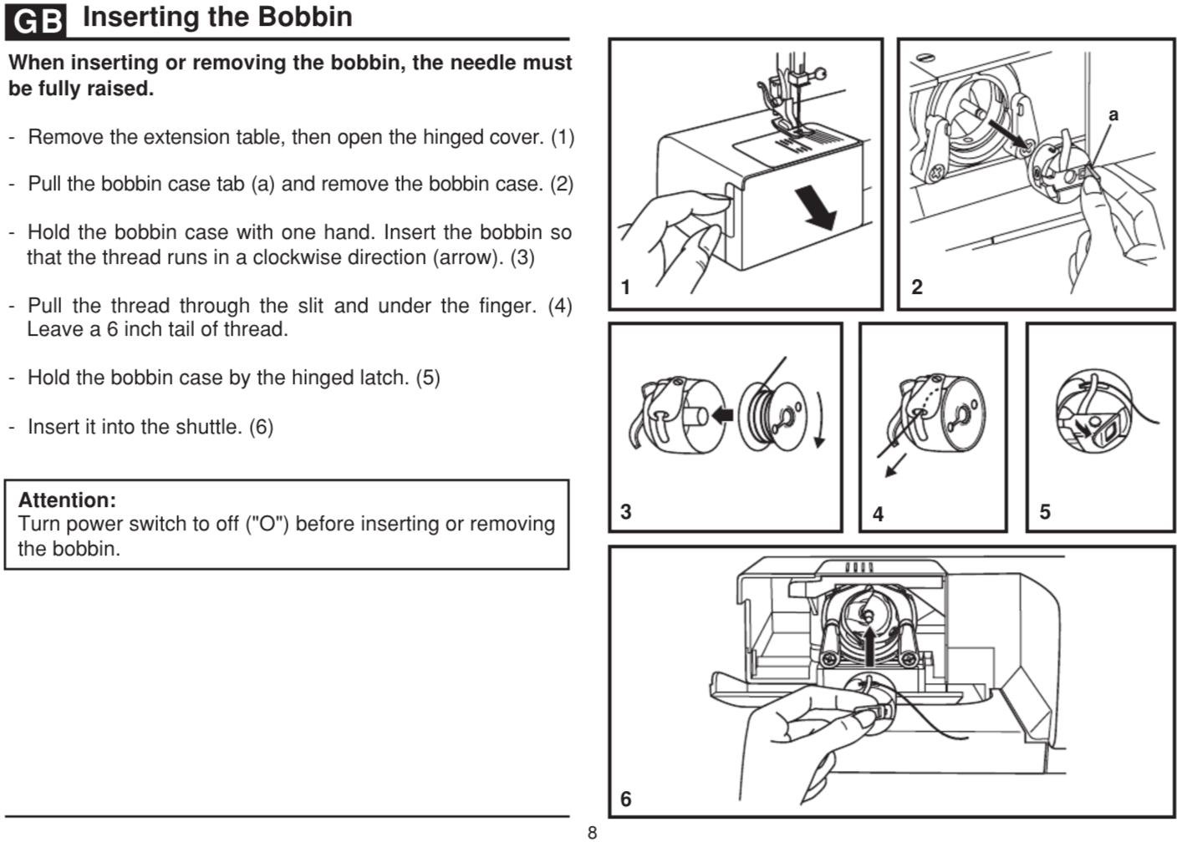
12

Inserting the Bobbin
When inserting or removing the bobbin, the needle mustbe fully raised.
- Remove the extension table, then open the hinged cover. (1)
- Pull the bobbin case tab (a) and remove the bobbin case. (2)
- Hold the bobbin case with one hand. Insert the bobbin sothat the thread runs in a clockwise direction (arrow). (3)
- Pull the thread through the slit and under the finger. (4) Leave a 6 inch tail of thread.
- Hold the bobbin case by the hinged latch. (5)
- Insert it into the shuttle. (6)
Attention:
Turn power switch to off ("O") before inserting or removing the bobbin.

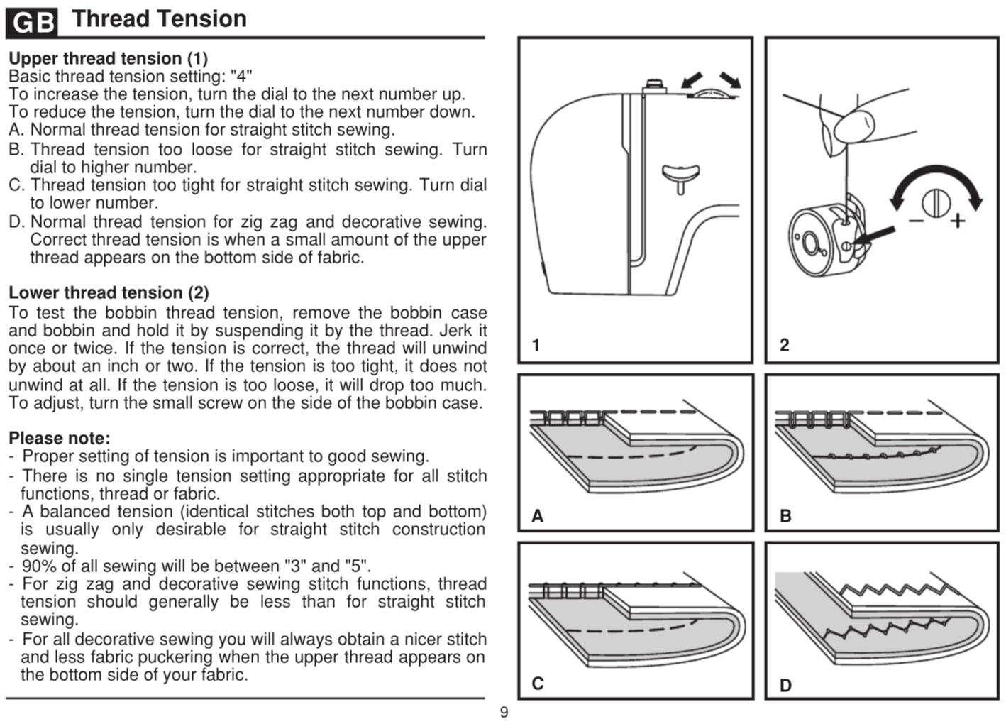
Thread Tension
Upper thread tension (1)
Lower thread tension (2)
Please note:
Basic thread tension setting: "4"
To increase the tension, turn the dial to the next number up.
To reduce the tension, turn the dial to the next number down.
A. Normal thread tension for straight stitch sewing.
B. Thread tension too loose for straight stitch sewing. Turn dial to higher number.
C. Thread tension too tight for straight stitch sewing. Turn dial to lower number.
D. Normal thread tension for zig zag and decorative sewing.
Correct thread tension is when a small amount of the upper thread appears on the bottom side of fabric.
To test the bobbin thread tension, remove the bobbin case and bobbin and hold it by suspending it by the thread. Jerk it once or twice. If the tension is correct, the thread will unwind by about an inch or two. If the tension is too tight, it does not unwind at all. If the tension is too loose, it will drop too much. To adjust, turn the small screw on the side of the bobbin case.
- Proper setting of tension is important to good sewing.
- There is no single tension setting appropriate for all stitch functions, thread or fabric.
- A balanced tension (identical stitches both top and bottom) is usually only desirable for straight stitch construction sewing.
- 90% of all sewing will be between "3" and "5".
- For zig zag and decorative sewing stitch functions, thread tension should generally be less than for straight stitch sewing.
- For all decorative sewing you will always obtain a nicer stitch and less fabric puckering when the upper thread appears on the bottom side of your fabric.GB
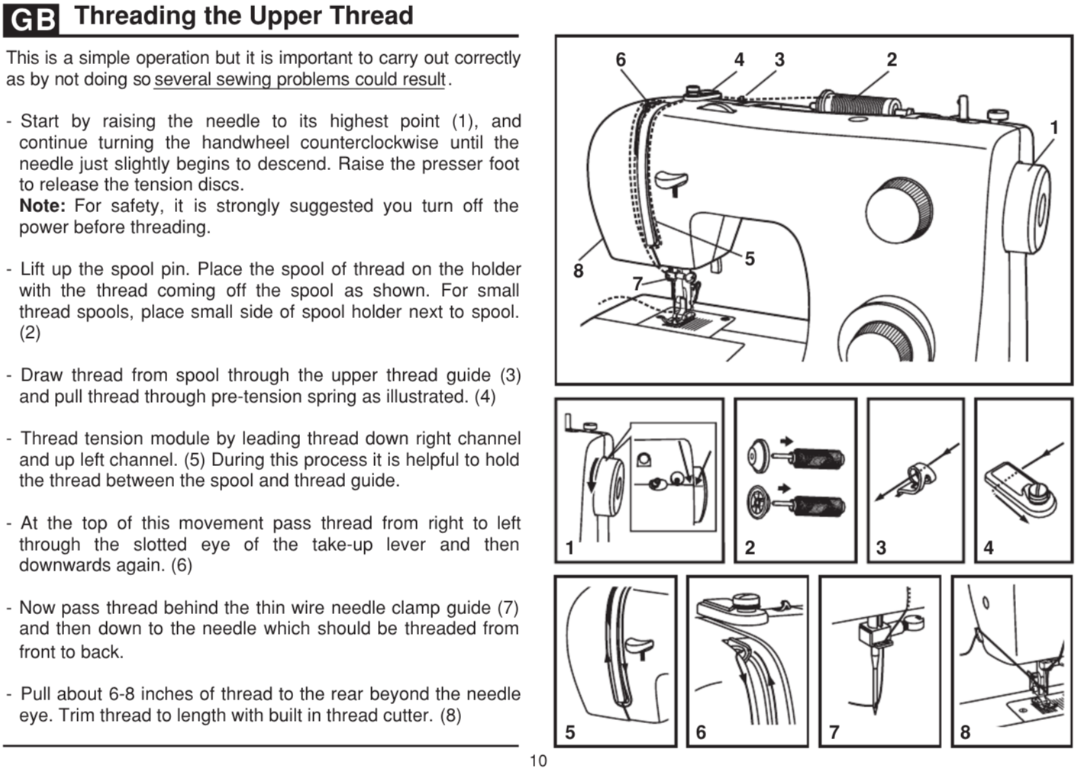
Threading the Upper Thread
This is a simple operation but it is important to carry out correctly as by not doing so several sewing problems could result.
- Start by raising the needle to its highest point (1), and continue turning the handwheel counterclockwise until the needle just slightly begins to descend. Raise the presser foot to release the tension discs.
- Lift up the spool pin. Place the spool of thread on the holder with the thread coming off the spool as shown. For small thread spools, place small side of spool holder next to spool. (2)
- Draw thread from spool through the upper thread guide (3) and pull thread through pre-tension spring as illustrated. (4)
- Thread tension module by leading thread down right channel and up left channel. (5) During this process it is helpful to hold the thread between the spool and thread guide.
- At the top of this movement pass thread from right to left through the slotted eye of the take-up lever and then downwards again. (6)
Note: For safety, it is strongly suggested you turn off the power before threading.
- Now pass thread behind the thin wire needle clamp guide (7) and then down to the needle which should be threaded from front to back.
- Pull about 6-8 inches of thread to the rear beyond the needle eye. Trim thread to length with built in thread cutter. (8)

GB
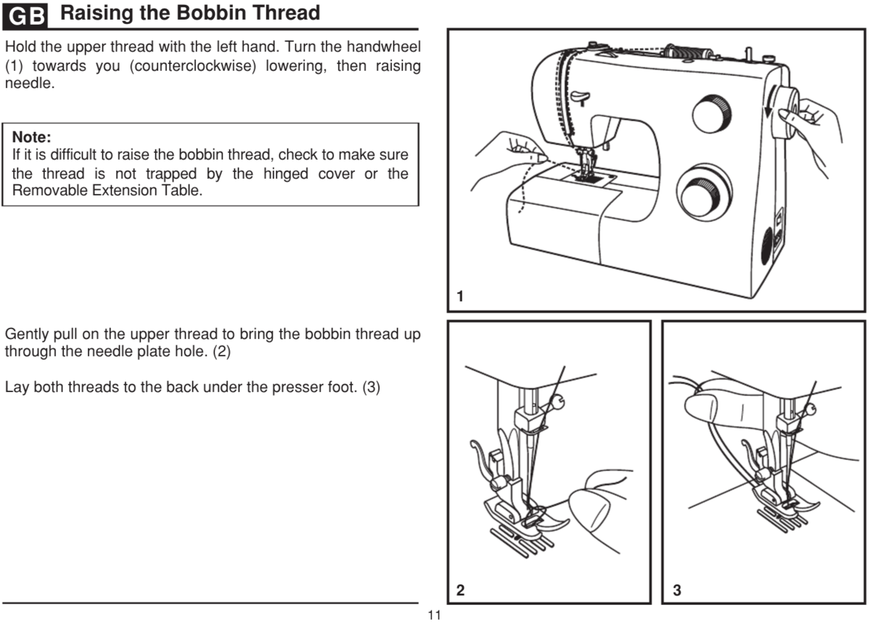
Raising the Bobbin Thread
Hold the upper thread with the left hand. Turn the handwheel (1) towards you (counterclockwise) lowering, then raising needle. If it is difficult to raise the bobbin thread, check to make sure the thread is not trapped by the hinged cover or the Removable Extension Table.
Gently pull on the upper thread to bring the bobbin thread up through the needle plate hole. (2)
Lay both threads to the back under the presser foot. (3)
Note: If it is difficult to raise the bobbin thread, check to make sure
the thread is not trapped by the hinged cover or the
Removable Extension Table.
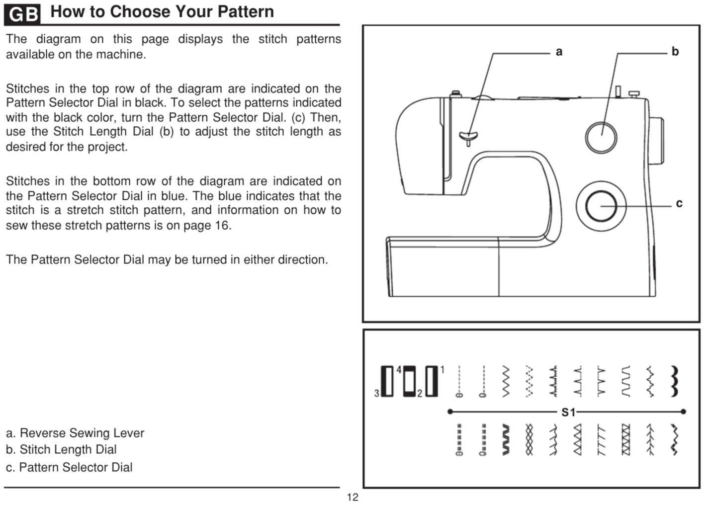
How to Choose Your Pattern
The diagram on this page displays the stitch patterns available on the machine.
Stitches in the top row of the diagram are indicated on the Pattern Selector Dial in black. To select the patterns indicated with the black color, turn the Pattern Selector Dial. (c) Then, use the Stitch Length Dial (b) to adjust the stitch length as desired for the project.
Stitches in the bottom row of the diagram are indicated on the Pattern Selector Dial in blue. The blue indicates that the stitch is a stretch stitch pattern, and information on how to sew these stretch patterns is on page 16. The Pattern Selector Dial may be turned in either direction.
a. Reverse Sewing Lever
b. Stitch Length Dial
c. Pattern Selector Dial
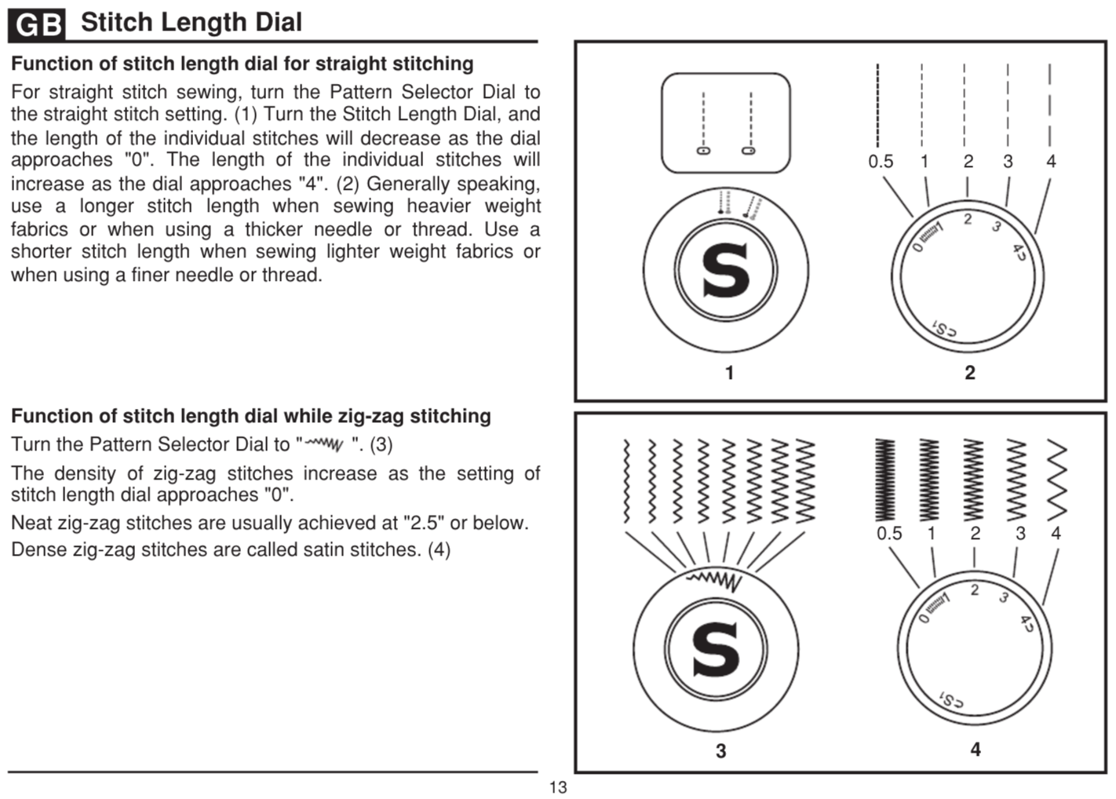Stitch Length Dial
Function of stitch length dial for straight stitching
Function of stitch length dial while zig-zag stitching
For straight stitch sewing, turn the Pattern Selector Dial to the straight stitch setting. (1) Turn the Stitch Length Dial, and the length of the individual stitches will decrease as the dial approaches "0". The length of the individual stitches will increase as the dial approaches "4". (2) Generally speaking, use a longer stitch length when sewing heavier weight fabrics or when using a thicker needle or thread. Use a shorter stitch length when sewing lighter weight fabrics or when using a finer needle or thread.
The density of zig-zag stitches increase as the setting of stitch length dial approaches "0".
Neat zig-zag stitches are usually achieved at "2.5" or below.
Dense zig-zag stitches are called satin stitches. (4)
Turn the Pattern Selector Dial to " ". (3)
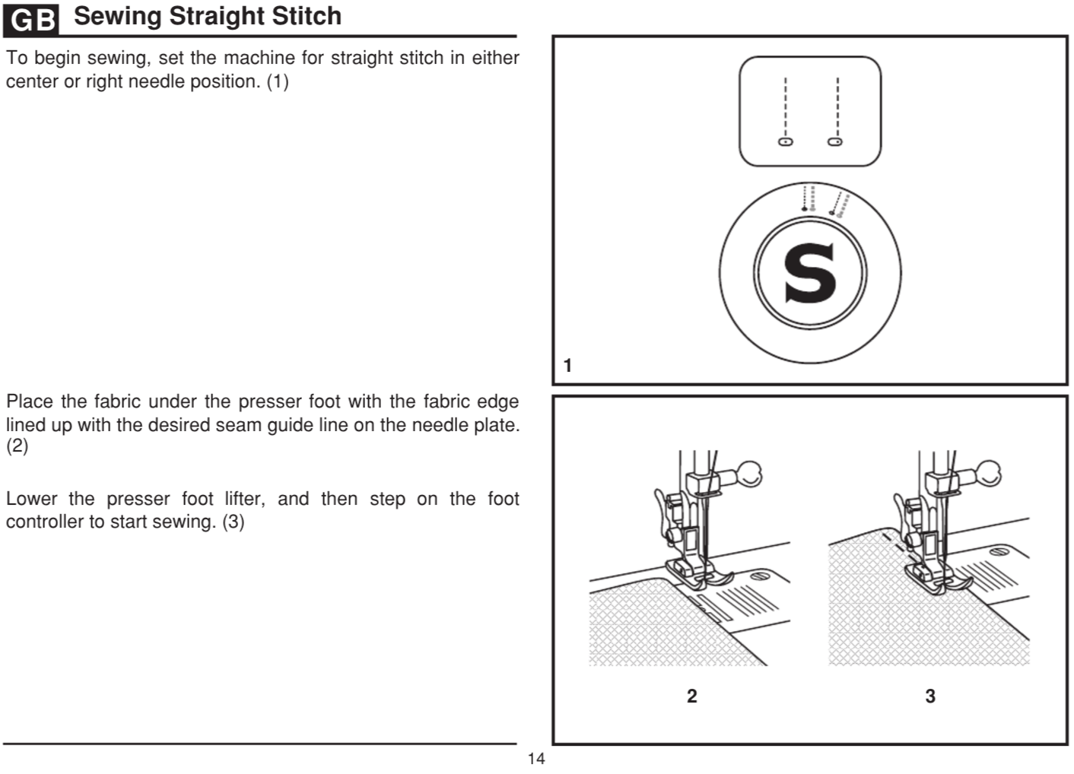
Sewing Straight Stitch
To begin sewing, set the machine for straight stitch in either center or right needle position. (1)
Place the fabric under the presser foot with the fabric edge lined up with the desired seam guide line on the needle plate. (2)
Lower the presser foot lifter, and then step on the foot controller to start sewing. (3)
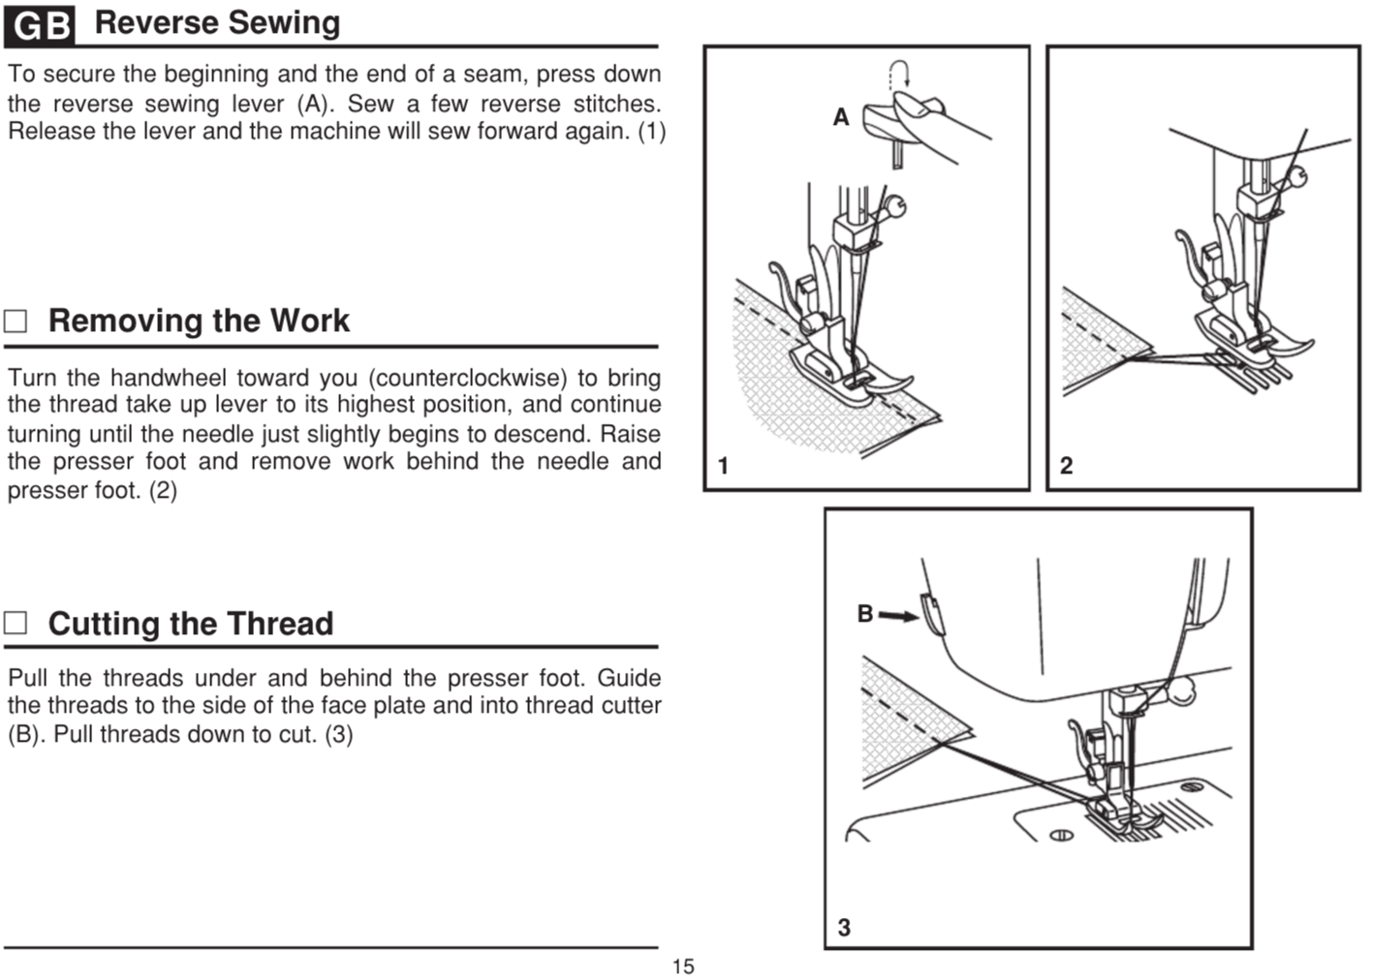
Reverse Sewing
To secure the beginning and the end of a seam, press down the reverse sewing lever (A). Sew a few reverse stitches. Release the lever and the machine will sew forward again. (1)
Removing the Work
Turn the handwheel toward you (counterclockwise) to bring the thread take up lever to its highest position, and continue turning until the needle just slightly begins to descend. Raise the presser foot and remove work behind the needle and presser foot. (2)
Cutting the Thread
Pull the threads under and behind the presser foot. Guide the threads to the side of the face plate and into thread cutter (B). Pull threads down to cut. (3)
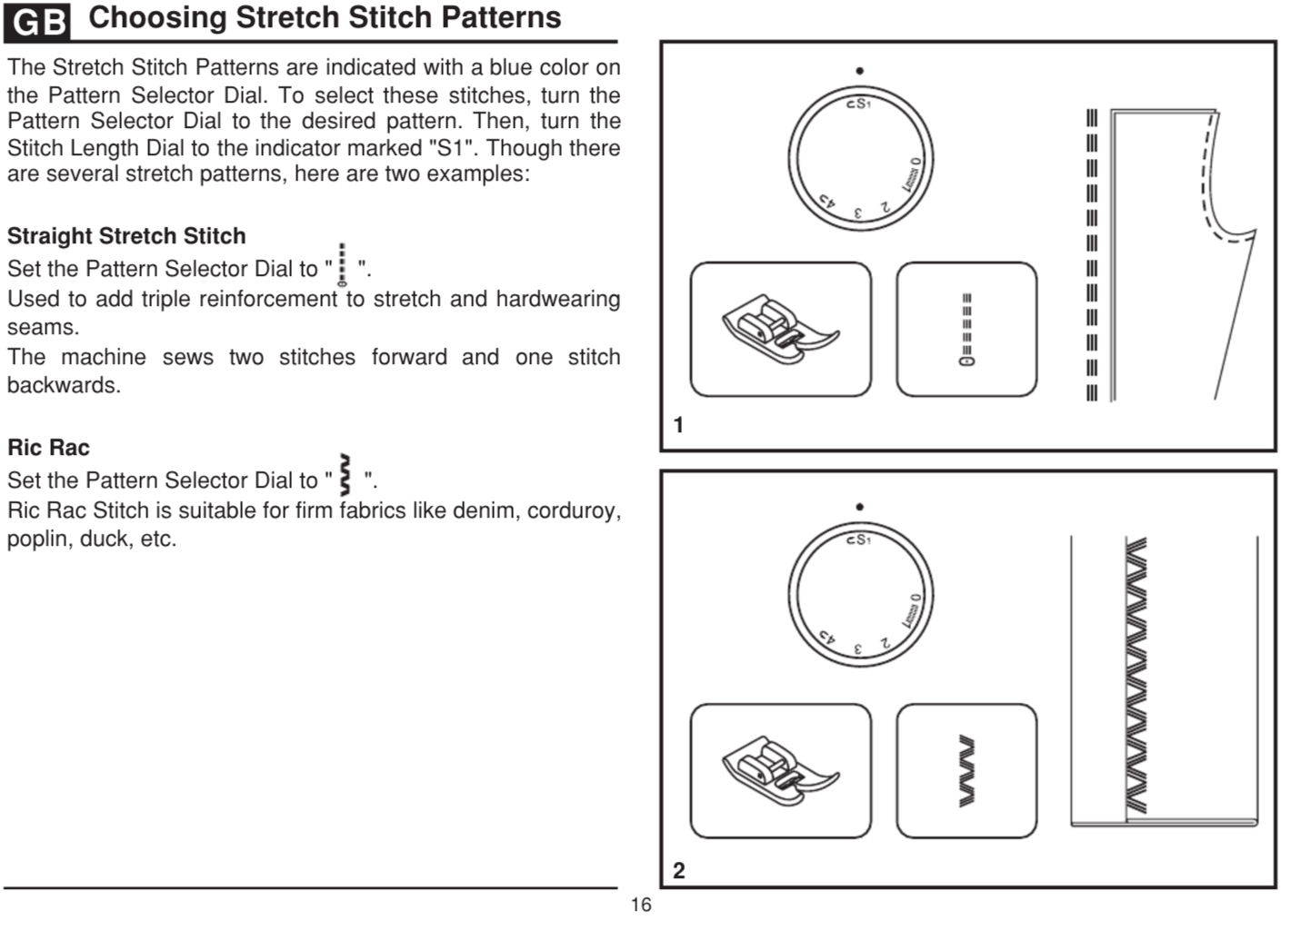
Choosing Stretch Stitch Patterns
The Stretch Stitch Patterns are indicated with a blue color on the Pattern Selector Dial. To select these stitches, turn the Pattern Selector Dial to the desired pattern. Then, turn the Stitch Length Dial to the indicator marked "S1". Though there are several stretch patterns, here are two examples:
Straight Stretch Stitch
Set the Pattern Selector Dial to " ".
Used to add triple reinforcement to stretch and hardwearing seams. The machine sews two stitches forward and one stitch backwards.
Ric Rac
Set the Pattern Selector Dial to " ". Ric Rac Stitch is suitable for firm fabrics like denim, corduroy, poplin, duck, etc.
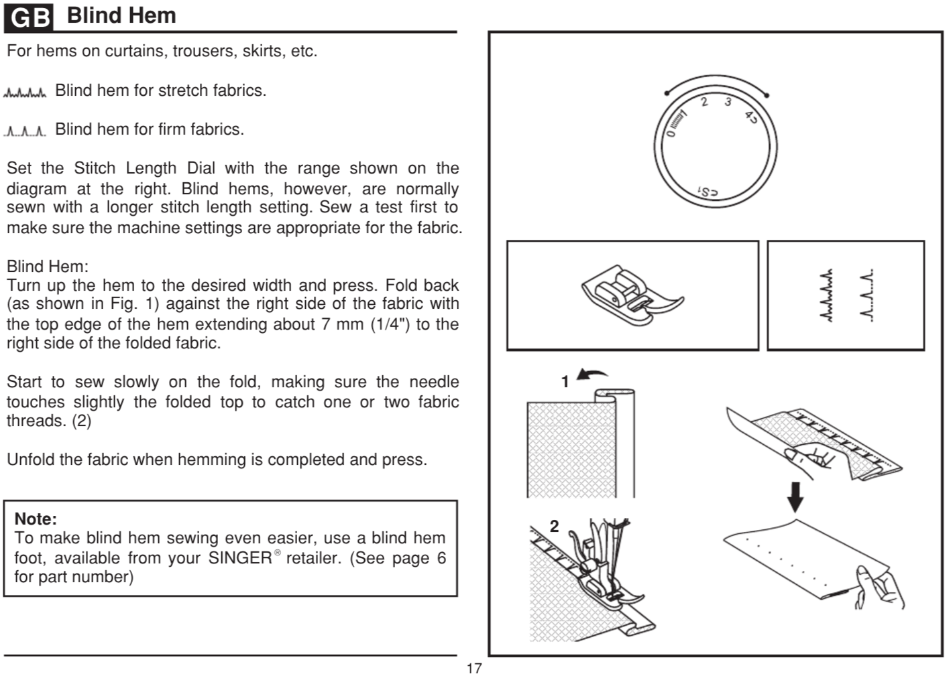
Blind Hem
For hems on curtains, trousers, skirts, etc.
Blind hem for stretch fabrics.
Blind hem for firm fabrics.
Set the Stitch Length Dial with the range shown on the diagram at the right. Blind hems, however, are normally sewn with a longer stitch length setting. Sew a test first to make sure the machine settings are appropriate for the fabric.
Blind Hem:
Turn up the hem to the desired width and press. Fold back (as shown in Fig. 1) against the right side of the fabric with the top edge of the hem extending about 7 mm (1/4") to the right side of the folded fabric.
Start to sew slowly on the fold, making sure the needle touches slightly the folded top to catch one or two fabric threads. (2)
Unfold the fabric when hemming is completed and press.
Note: To make blind hem sewing even easier, use a blind hem foot, available from your SINGER retailer. (See page 6 for part number)

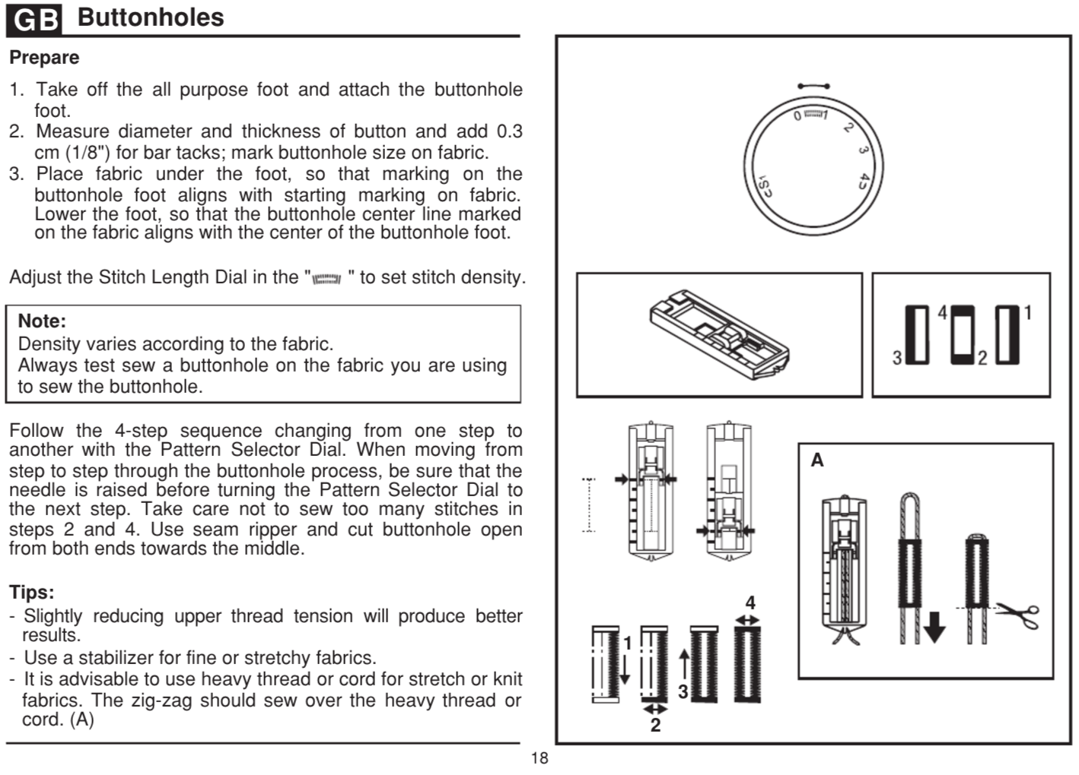
Buttonholes 18
Prepare
1. Take off the all purpose foot and attach the buttonhole foot.
2. Measure diameter and thickness of button and add 0.3 cm (1/8") for bar tacks; mark buttonhole size on fabric.
3. Place fabric under the foot, so that marking on the buttonhole foot aligns with starting marking on fabric. Lower the foot, so that the buttonhole center line marked on the fabric aligns with the center of the buttonhole foot.
Adjust the Stitch Length Dial in the " " to set stitch density.

Note: Density varies according to the fabric. Always test sew a buttonhole on the fabric you are using to sew the buttonhole.
Follow the 4-step sequence changing from one step to another with the Pattern Selector Dial. When moving from step to step through the buttonhole process, be sure that the needle is raised before turning the Pattern Selector Dial to the next step. Take care not to sew too many stitches in steps 2 and 4. Use seam ripper and cut buttonhole open from both ends towards the middle.
Tips:
- Slightly reducing upper thread tension will produce better results.
- Use a stabilizer for fine or stretchy fabrics.
- It is advisable to use heavy thread or cord for stretch or knit fabrics. The zig-zag should sew over the heavy thread or cord. (A)

B
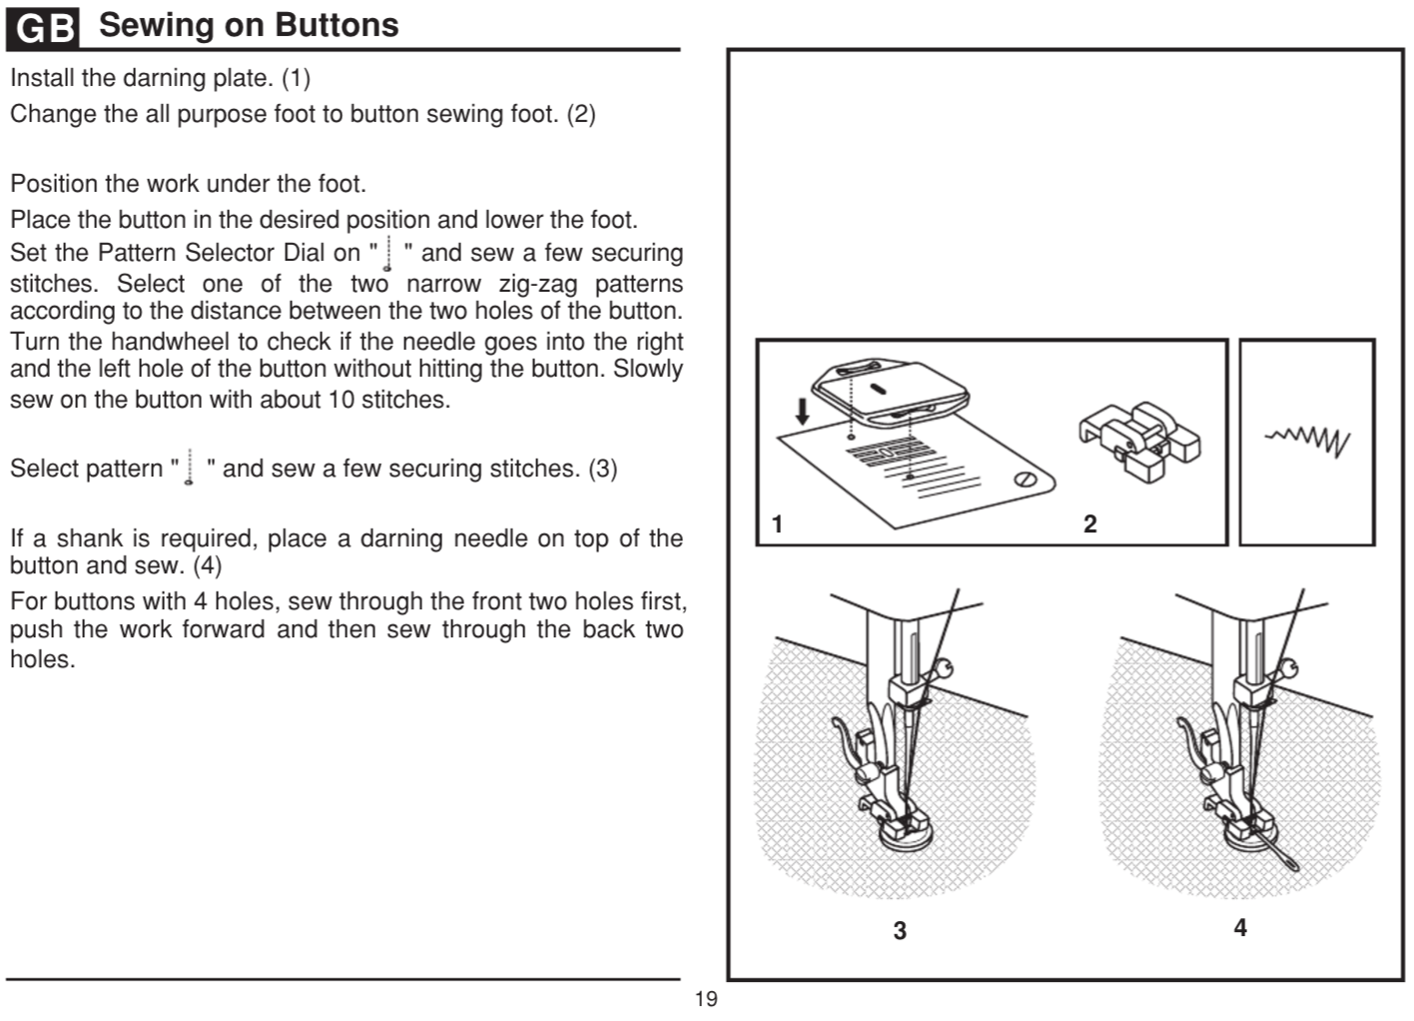Sewing on Buttons 19
Install the darning plate. (1)
Change the all purpose foot to button sewing foot. (2)
Position the work under the foot.
Place the button in the desired position and lower the foot. Set the Pattern Selector Dial on " " and sew a few securing stitches. Select one of the two narrow zig-zag patterns according to the distance between the two holes of the button. Turn the handwheel to check if the needle goes into the right and the left hole of the button without hitting the button. Slowly sew on the button with about 10 stitches.
Select pattern " " and sew a few securing stitches. (3)
If a shank is required, place a darning needle on top of the button and sew. (4)
For buttons with 4 holes, sew through the front two holes first, push the work forward and then sew through the back two holes.GB
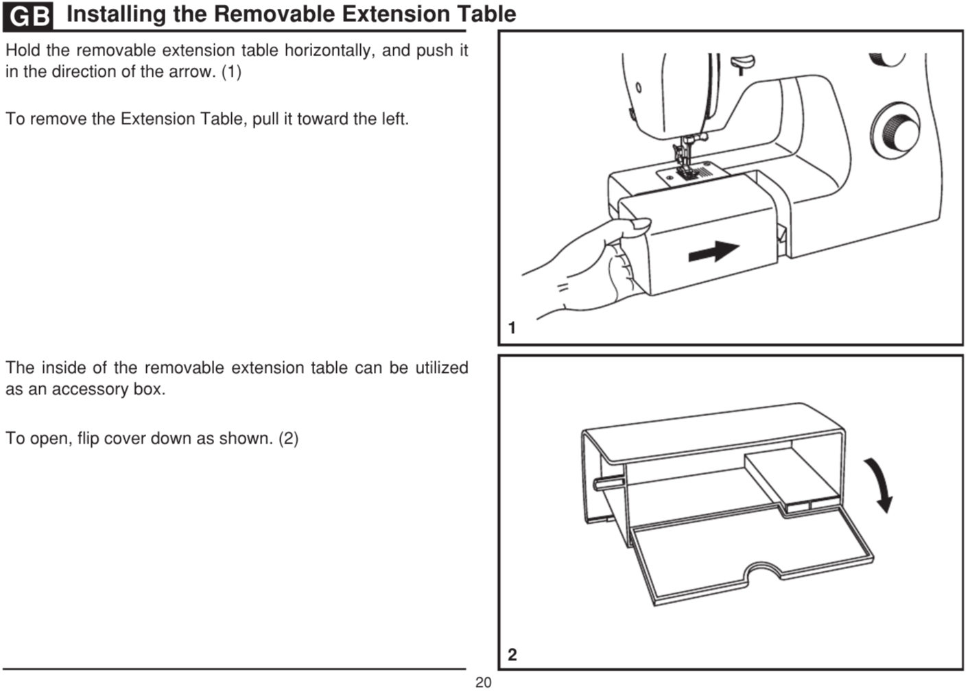
Installing the Removable Extension Table 20
Hold the removable extension table horizontally, and push it in the direction of the arrow. (1)
To remove the Extension Table, pull it toward the left.
The inside of the removable extension table can be utilized as an accessory box.
To open, flip cover down as shown. (2)GB
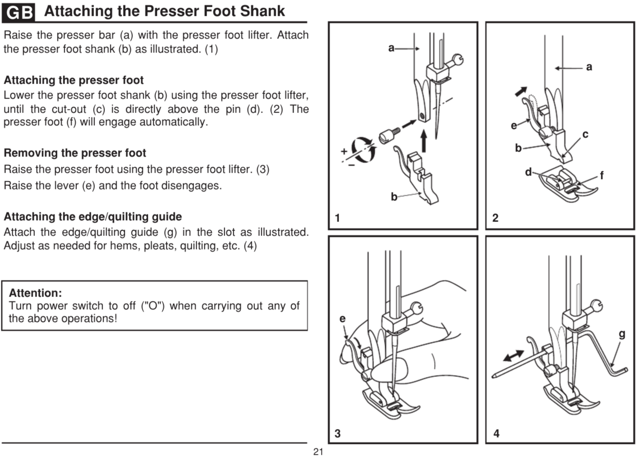
Attaching the Presser Foot Shank 21
Raise the presser bar (a) with the presser foot lifter. Attach the presser foot shank (b) as illustrated. (1)
Attaching the presser foot
Lower the presser foot shank (b) using the presser foot lifter, until the cut-out (c) is directly above the pin (d). (2) The presser foot (f) will engage automatically.
Removing the presser foot
Raise the presser foot using the presser foot lifter. (3) Raise the lever (e) and the foot disengages.
Attaching the edge/quilting guide
Attach the edge/quilting guide (g) in the slot as illustrated. Adjust as needed for hems, pleats, quilting, etc. (4)
Attention:
Turn power switch to off ("O") when carrying out any of the above operations!

GB
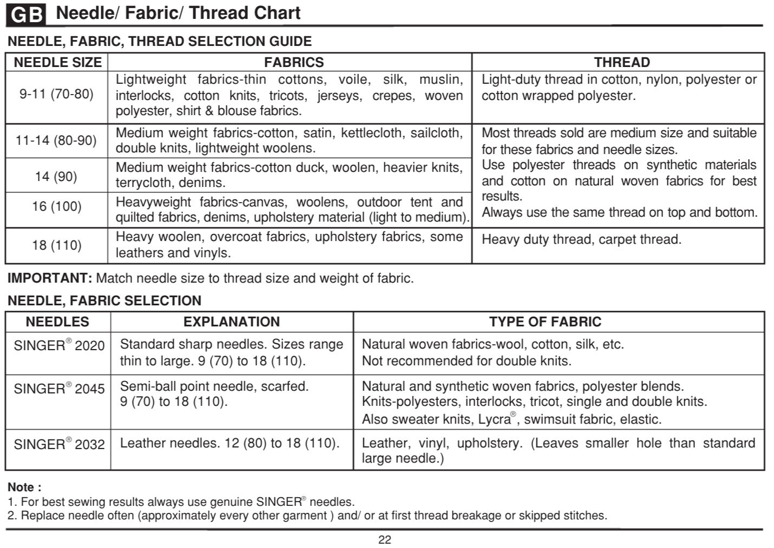
N Charteedle/ Fabric/ Thread 22
NEEDLE, FABRIC SELECTION
NEEDLES, EXPLANATION, TYPE OF FABRIC
SINGER 2020 → Standard sharp needles. Sizes range thin to large. 9 (70) to 18 (110). → Natural woven fabrics-wool, cotton, silk, etc. Not recommended for double knits.
SINGER 2045 → Semi-ball point needle, scarfed. 9 (70) to 18 (110). → Natural and synthetic woven fabrics, polyester blends. Knits-polyesters, interlocks, tricot, single and double knits. Also sweater knits, Lycra , swimsuit fabric, elastic.
SINGER 2032 → Leather needles. 12 (80) to 18 (110). → Leather, vinyl, upholstery. (Leaves smaller hole than standard large needle.)
IMPORTANT: Match needle size to thread size and weight of fabric.
NEEDLE, FABRIC, THREAD SELECTION GUIDE
NEEDLE, SIZE FABRICS, THREAD
Lightweight fabrics-thin cottons, voile, silk, muslin, interlocks, cotton knits, tricots, jerseys, crepes, woven polyester, shirt & blouse fabrics.→
Light-duty thread in cotton, nylon, polyester or cotton wrapped polyester.
---------
Medium weight fabrics-cotton duck, woolen, heavier knits, terrycloth, denims.
Medium weight fabrics-cotton, satin, kettlecloth, sailcloth, double knits, lightweight woolens.
Heavyweight fabrics-canvas, woolens, outdoor tent and quilted fabrics, denims, upholstery material (light to medium).→
Most threads sold are medium size and suitable for these fabrics and needle sizes. Use polyester threads on synthetic materials and cotton on natural woven fabrics for best results. Always use the same thread on top and bottom.
---------
Heavy woolen, overcoat fabrics, upholstery fabrics, some leathers and vinyls. → Heavy duty thread, carpet thread.
Note :
1. For best sewing results always use genuine SINGER needles.
2. Replace needle often (approximately every other garment ) and/ or at first thread breakage or skipped stitches.GB
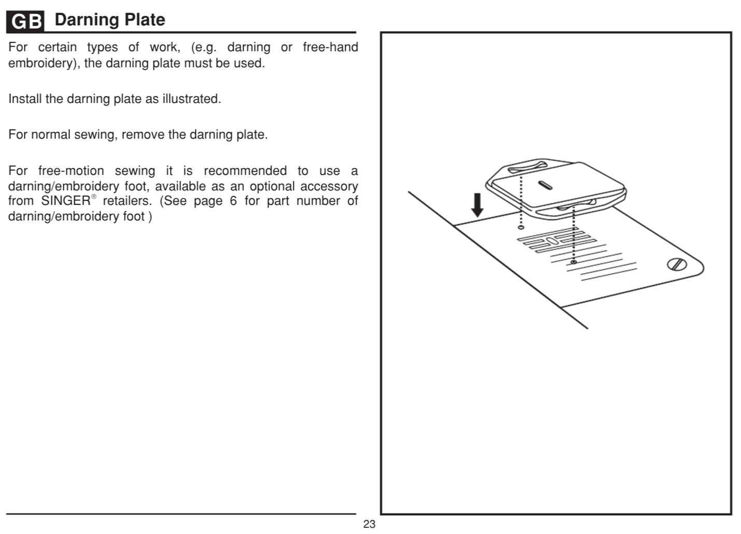
Darning Plate 23
For certain types of work, (e.g. darning or free-hand embroidery), the darning plate must be used.
Install the darning plate as illustrated.
For normal sewing, remove the darning plate.
For free-motion sewing it is recommended to use a darning/embroidery foot, available as an optional accessory from SINGER retailers. (See page 6 for part number of darning/embroidery foot )GB
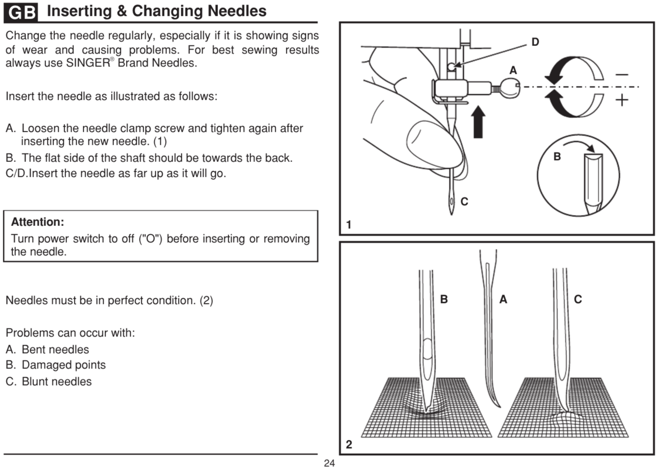
Inserting & Changing Needles
Change the needle regularly, especially if it is showing signs of wear and causing problems. For best sewing results always use SINGER Brand Needles.
Insert the needle as illustrated as follows:
A. Loosen the needle clamp screw and tighten again after inserting the new needle. (1)
B. The flat side of the shaft should be towards the back.
C/D. Insert the needle as far up as it will go.

Attention:
Turn power switch to off ("O") before inserting or removing the needle.
Needles must be in perfect condition. (2)
Problems can occur with:
A. Bent needles
B. Damaged points
C. Blunt needles

GB

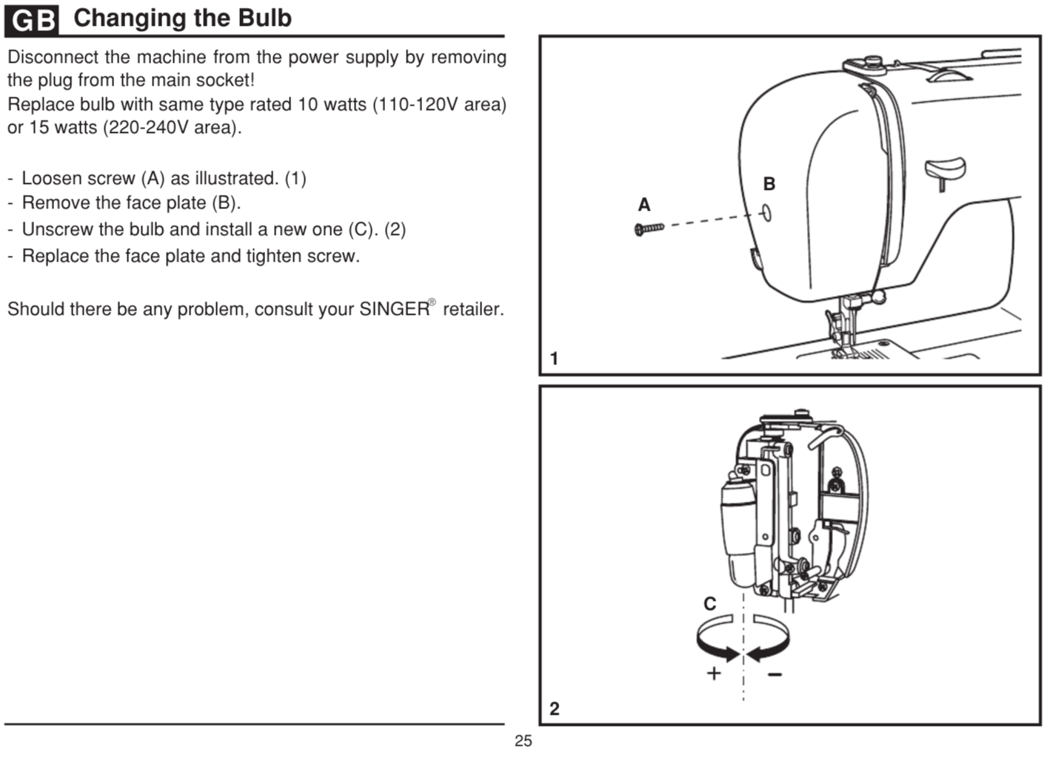
Changing the Bulb 25
Disconnect the machine from the power supply by removing the plug from the main socket!
Replace bulb with same type rated 10 watts (110-120V area) or 15 watts (220-240V area).
- Loosen screw (A) as illustrated. (1)
- Remove the face plate (B).
- Unscrew the bulb and install a new one (C). (2)
- Replace the face plate and tighten screw.
Should there be any problem, consult your SINGER retailer.
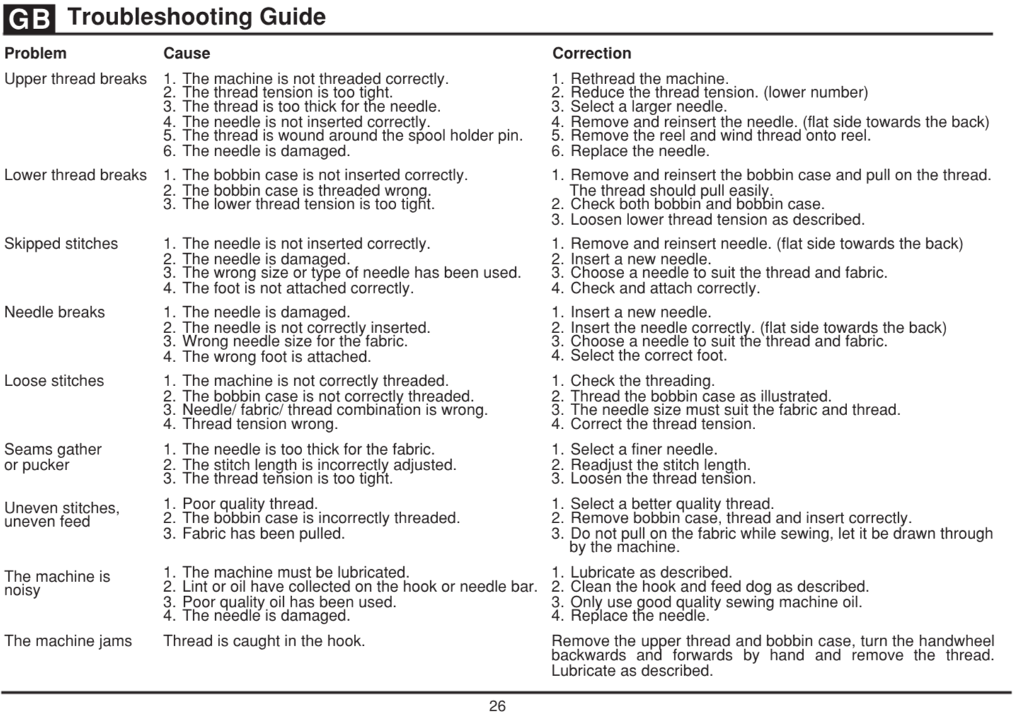
Troubleshooting Guide 26
Problem, Cause, Correction
Upper thread breaks
1. The machine is not threaded correctly.
2. The thread tension is too tight.
3. The thread is too thick for the needle.
4. The needle is not inserted correctly.
5. The thread is wound around the spool holder pin.
6. The needle is damaged.

1. Rethread the machine.
2. Reduce the thread tension. (lower number)
3. Select a larger needle.
4. Remove and reinsert the needle. (flat side towards the back)
5. Remove the reel and wind thread onto reel.
6. Replace the needle.
Lower thread breaks
1. The bobbin case is not inserted correctly.
2. The bobbin case is threaded wrong.
3. The lower thread tension is too tight.

1. Remove and reinsert the bobbin case and pull on the thread.
The thread should pull easily.
2. Check both bobbin and bobbin case.
3. Loosen lower thread tension as described.

Skipped stitches
1. The needle is not inserted correctly.
2. The needle is damaged.
3. The wrong size or type of needle has been used.
4. The foot is not attached correctly.

1. Remove and reinsert needle. (flat side towards the back)
2. Insert a new needle.
3. Choose a needle to suit the thread and fabric.
4. Check and attach correctly.

Needle breaks
1. The needle is damaged.
2. The needle is not correctly inserted.
3. Wrong needle size for the fabric.
4. The wrong foot is attached.

1. Insert a new needle.
2. Insert the needle correctly. (flat side towards the back)
3. Choose a needle to suit the thread and fabric.
4. Select the correct foot.

Loose stitches
1. The machine is not correctly threaded.
2. The bobbin case is not correctly threaded.
3. Needle/ fabric/ thread combination is wrong.
4. Thread tension wrong.

1. Check the threading.
2. Thread the bobbin case as illustrated.
3. The needle size must suit the fabric and thread.
4. Correct the thread tension.

Seams gather or pucker
1. The needle is too thick for the fabric.
2. The stitch length is incorrectly adjusted.
3. The thread tension is too tight.

1. Select a finer needle.
2. Readjust the stitch length.
3. Loosen the thread tension.

Uneven stitches, uneven feed
1. Poor quality thread.
2. The bobbin case is incorrectly threaded.
3. Fabric has been pulled.

1. Select a better quality thread.
2. Remove bobbin case, thread and insert correctly.
3. Do not pull on the fabric while sewing, let it be drawn through by the machine.
The machine is noisy
1. The machine must be lubricated.
2. Lint or oil have collected on the hook or needle bar.
3. Poor quality oil has been used.
4. The needle is damaged.

1. Lubricate as described.
2. Clean the hook and feed dog as described.
3. Only use good quality sewing machine oil.
4. Replace the needle.

The machine jams
Thread is caught in the hook.

Remove the upper thread and bobbin case, turn the handwheel backwards and forwards by hand and remove the thread. Lubricate as described.

